Bistro Application
User Guide

TABLE OF CONTENTS
1 Purpose of this document 1
1.1 Definitions, acronyms and abbreviations 1
1.2 Document Change REcord 1
2 INstalation 2
3 uTILISATION 3
3.1 mOCK Application 3
3.2 Bistro Application 4

Purpose of this document
This document is a User Guide document for use by Bistro solution. It provides guidance which is intended to assist the relevant management or technical staff, whether client or administrator, in using and deploying the current solution.

Definitions, acronyms and abbreviations
Term | Definition
Administrator | This is anyone that has been given administrative rights in the Bistro application.
User | This is anyone that is using the application for making a command at the company bistro.
AC | Access Control System
ERP | Enterprise Resource Planning

Document Change REcord
Date | Version | Author | Change details
13 April 2019 | V1.0 | Mihai Olaru | Initial release

INstalation
In order to use de application the solution package bistro.zip must be unzipped in a location chosen by the user.

The package contains two main files:
- BistroApp.exe → bistro application file;
- MockAPI.exe → mock application used to simulate the ERP system for food bills transactions and the AC system for giving login and access.

Both files must be run with administrative rights in order to work correctly. Also need to be assured that the ports 1234 and 4567 are not blocked by the firewall because are used by the mock API and Bistro application.

uTILISATION

mOCK Application

The mock application it’s simulating the system of access control and the ERP system.

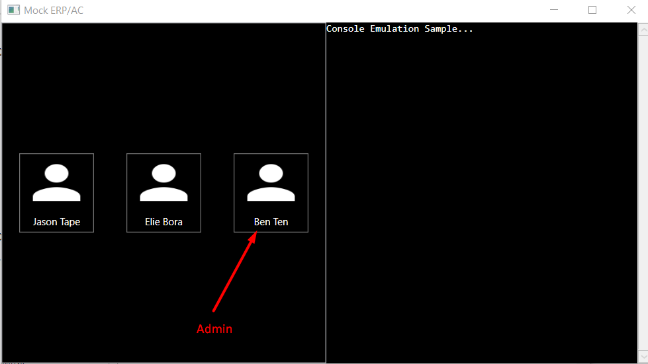

Figure 1 Mock Application

Clicking on a user will send the credentials to the Bistro application. This will simulate a user badging his card.

The Mock application right side is a console that will receive all transactions that have been confirmed in Bistro. The information will be in JSON format all will contain transaction informations that in a production environment will go to the ERP system.

Bistro Application

Login page

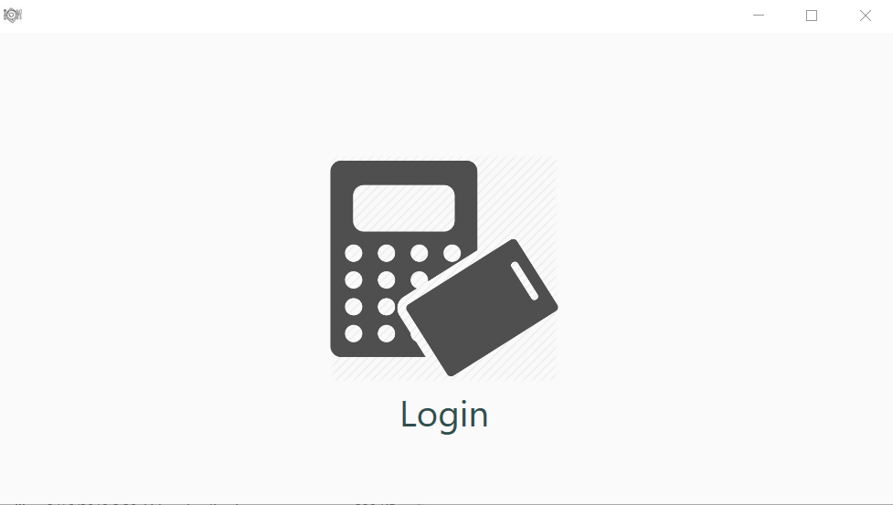

Figure 2 Login Page

The application will show the login page until a user is logged in.

Main Page

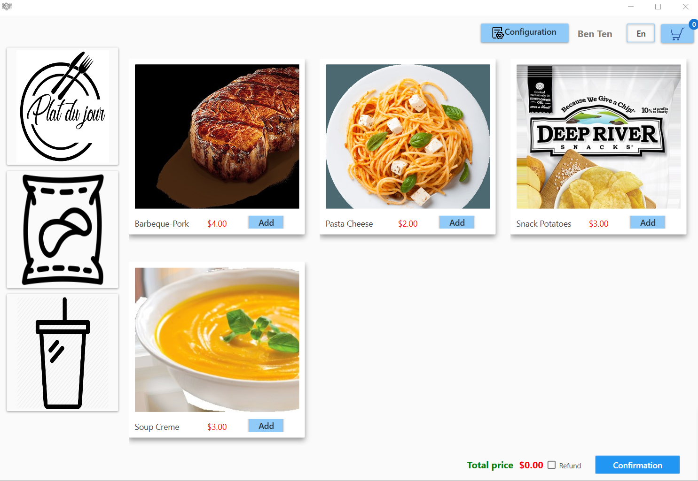

Figure 3 Main Page

The main page is composed from the following items:

side menu from were can be selected different categoris of food items;

the products section conaining food items loaded from the database that can be added to the basket;

the button Configuration that can be visible only for the users with admin rights;

the button Language from where the user can change the language dynamically between English and French;

Refund checkbox visible only for the users with admin rights and which will allow to make a refund (the total will became negative).

Configuration

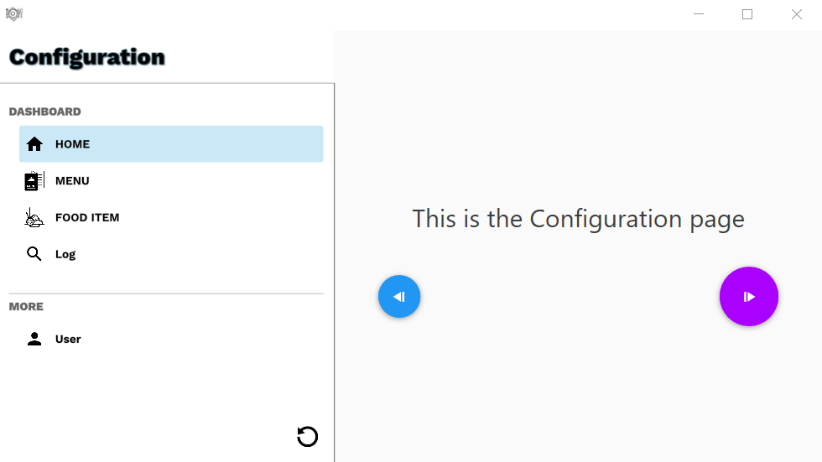

Figure 4 Configuration window

From the configuration page the administrator can do the following actions:

See all the food items that are saved into the database, creating new items, modifying or deleting the existing ones;

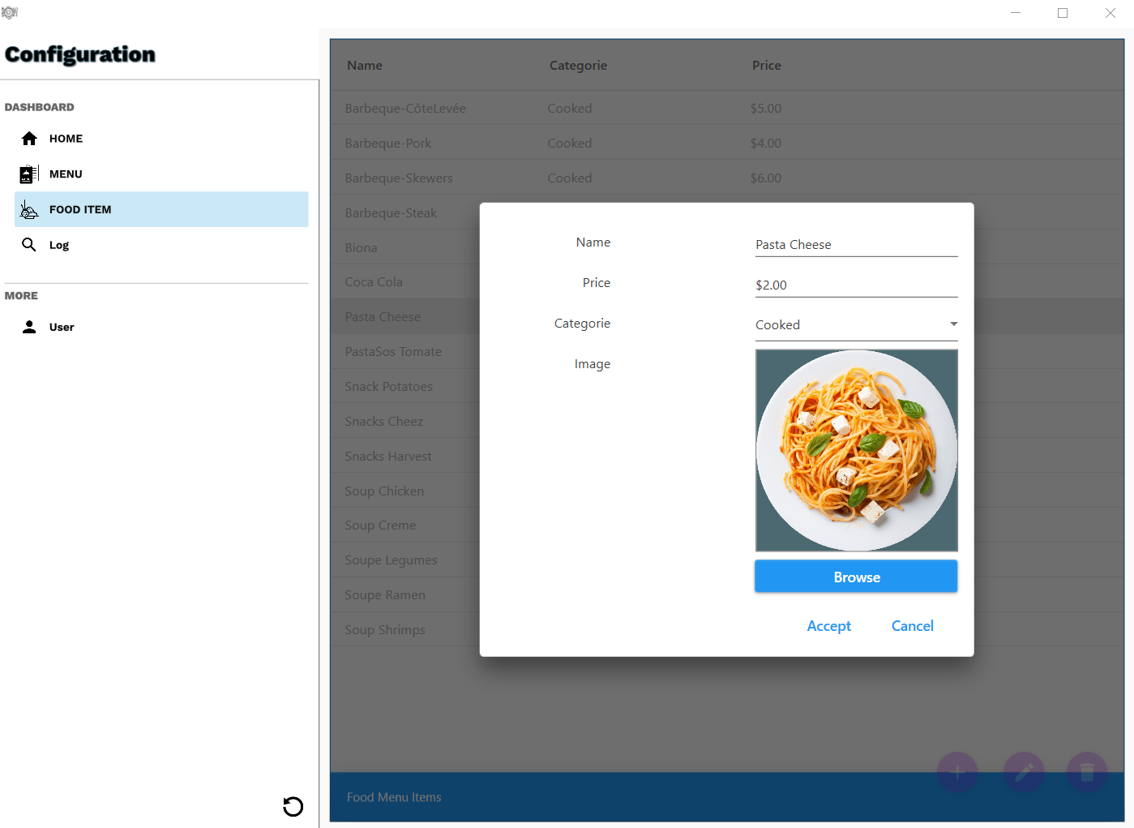

Figure 5 Food product configuration

See all the daily menu items that are saved into the database, creating new items for specific days, modifying or deleting the existing ones;

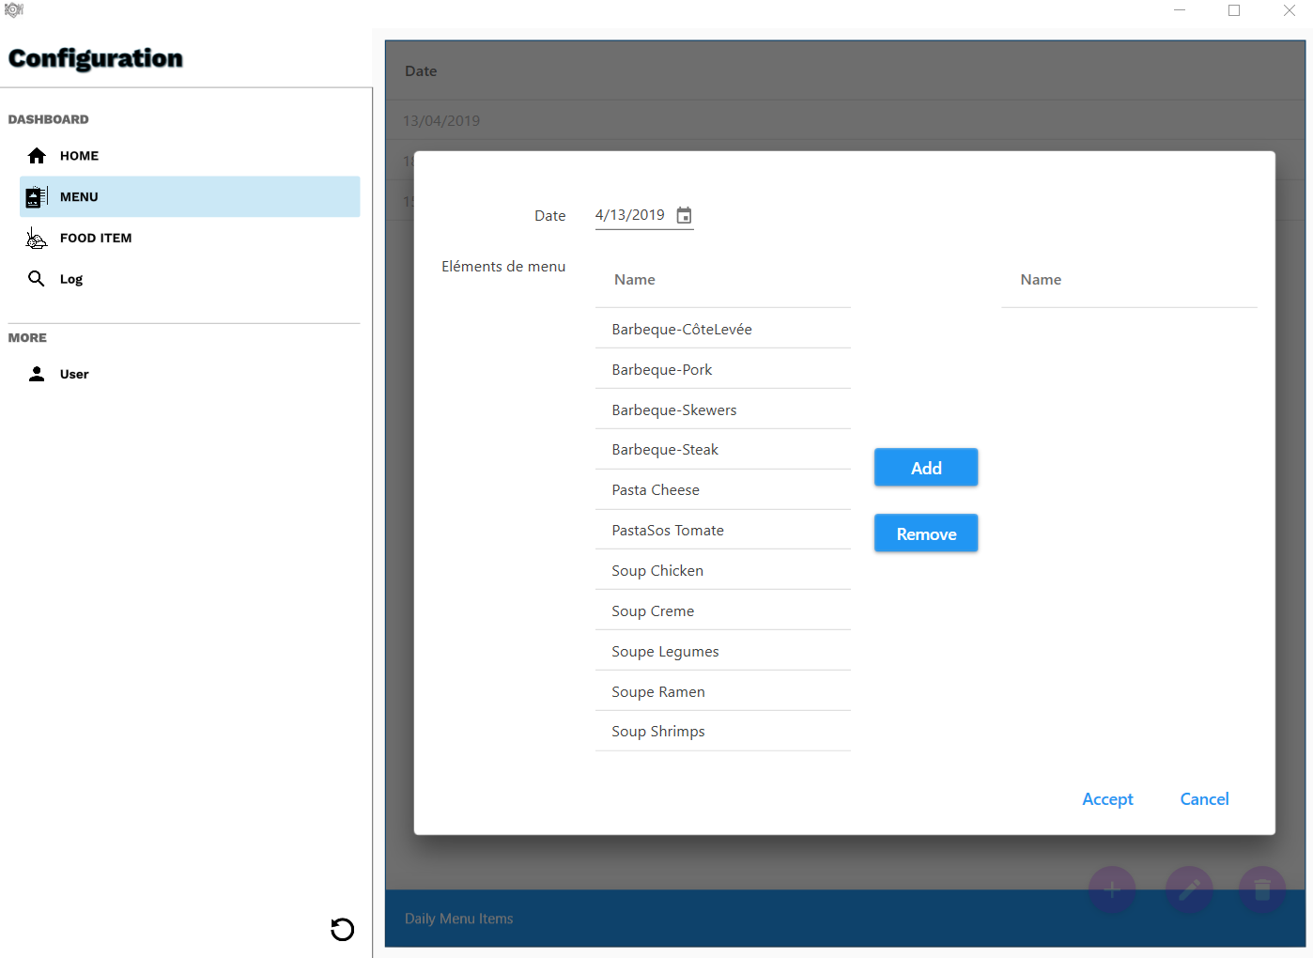

Figure 6 Daily menu configuration

See all the logs.

